Corso di Basi di Dati 2

Progettazione Logica

a.a. 2017/18

Attilio Lughetta

Giusy Gaudino

Numero di record 2.000.000

Numero di inserimenti 400 (da 5.000 record ciascuno)

Valutazione tempi:

* Inserimenti
* Indici sulle gerarchie (presenza e assenza)
* Viste materializzate (presenza e assenza)
* Frammentazione

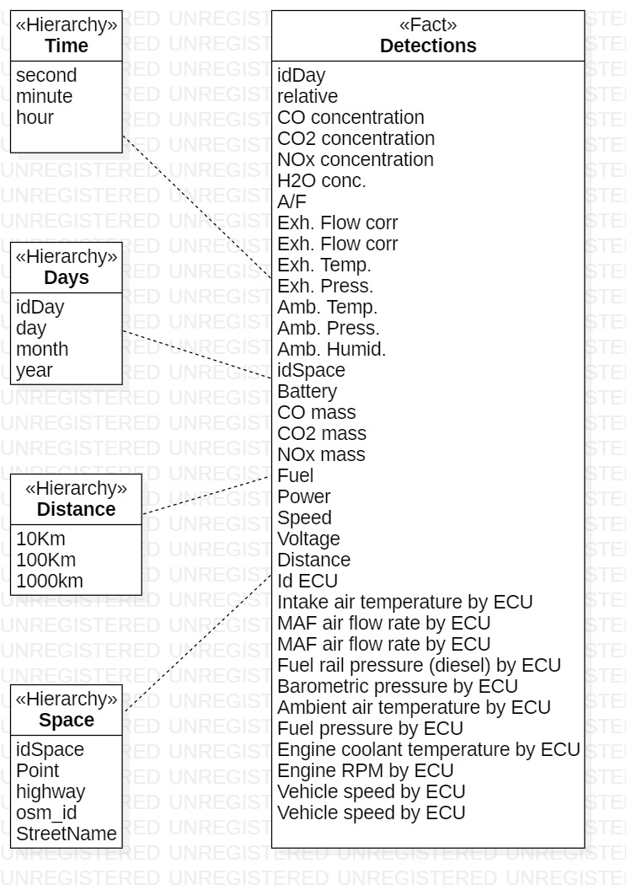

Query 1

Sulla gerarchia del tempo trascorso, media delle emissioni per test (Co concentration/mass, CO2 concentration/mass, NOx concentration, H2O concentration e Fuel)

|  |  |  |  |  |  |
| --- | --- | --- | --- | --- | --- |
| **Second** | **Co conc.** | **Co mass** | **CO2 conc.** | **CO2 mass** | **…** |
| 1 | xxx | Yyy | Zzz | rrr | … |
| 2 | sss | Ttt | Uuu | vvv | … |

|  |  |  |  |  |  |
| --- | --- | --- | --- | --- | --- |
| **Minute** | **Co conc.** | **Co mass** | **CO2 conc.** | **CO2 mass** | **…** |
| 1 | xxx | Yyy | Zzz | Rrr | … |
| 2 | sss | Ttt | Uuu | Vvv | … |

|  |  |  |  |  |  |
| --- | --- | --- | --- | --- | --- |
| **Hour** | **Co conc.** | **Co mass** | **CO2 conc.** | **CO2 mass** | **…** |
| 1 | xxx | Yyy | Zzz | Rrr | … |
| 2 | sss | Ttt | Uuu | Vvv | … |

Query 2

Per tipologia di strada, per test, media dei valori Power, Speed, Voltage, Battery.

|  |  |  |  |  |  |
| --- | --- | --- | --- | --- | --- |
| **Highway** | **idTest** | **Power** | **Speed** | **Voltage** | **Battery** |
| Autostrada | 1 | x | y | z | R |
|  | 2 | s | t | u | V |
| Strada provinciale | 1 | j | k | l | M |

Query 3

Temperatura dello scarico e carburante consumato medi al secondo per kilometro e tipo di strada.

|  |  |  |  |
| --- | --- | --- | --- |
| **Tipo di strada** | **Kilometro** | **Exh. Temp** | **Fuel** |
| Autostrada | 1 km | X | Y |
|  | 2 km | Z | T |
| Strada provinciale | 1 km | R | S |

Query 4

Valori ECU media su secondi trascorsi e gerarchia giorno.

|  |  |  |  |  |  |
| --- | --- | --- | --- | --- | --- |
| **Giorno** | **Tempo** | **Intake air temperature by ECU** | **MAF air flow rate by ECU** | **MAF air flow rate by ECU** | **…** |
| 1/1/2001 | 00:00:01 | Xxx | Yyy | Zzz | … |
|  | 00:00:02 | Rrr | Sss | Ttt | … |
| 2/1/2001 | 00:00:01 | Uuu | Vvv | Zzz | … |
|  | 00:00:02 | Jjj | Kkk | Lll | … |

|  |  |  |  |  |  |
| --- | --- | --- | --- | --- | --- |
| **Mese** | **Tempo** | **Intake air temperature by ECU** | **MAF air flow rate by ECU** | **MAF air flow rate by ECU** | **…** |
| 1/2001 | 00:00:01 | Xxx | Yyy | Zzz | … |
|  | 00:00:02 | Rrr | Sss | Ttt | … |
| 2/2001 | 00:00:01 | Uuu | Vvv | Zzz | … |
|  | 00:00:02 | Jjj | Kkk | Lll | … |

|  |  |  |  |  |  |
| --- | --- | --- | --- | --- | --- |
| **Anno** | **Tempo** | **Intake air temperature by ECU** | **MAF air flow rate by ECU** | **MAF air flow rate by ECU** | **…** |
| 2001 | 00:00:01 | Xxx | Yyy | Zzz | … |
|  | 00:00:02 | Rrr | Sss | Ttt | … |
| 2002 | 00:00:01 | Uuu | Vvv | Zzz | … |
|  | 00:00:02 | Jjj | Kkk | Lll | … |

Query 5

Valori ECU media su spazio e distanza (10 Km).

|  |  |  |  |  |  |
| --- | --- | --- | --- | --- | --- |
| **idStrada** | **Distanza** | **Intake air temperature by ECU** | **MAF air flow rate by ECU** | **MAF air flow rate by ECU** | **…** |
| 1 | 10 km | Xxx | Yyy | Zzz | … |
|  | 20 km | Rrr | Sss | Ttt | … |
| 2 | 10 km | Uuu | Vvv | Zzz | … |
|  | 20 km | Jjj | Kkk | Lll | … |

Query 6

Media su gerarchia giorni e su test (Exh. Flow. /Temp. / Press., Amb Temp. /Press. /Humid., A/F)

|  |  |  |  |  |
| --- | --- | --- | --- | --- |
| **Giorno** | **Exh. Flow** | **Exh. Temp.** | **Exh. Press** | **Amb Temp.** |
| 1/5/2012 | Xxx | Yyy | Zzz | Ttt |
| 2/5/2012 | Rrr | Sss | Uuu | Vvv |

|  |  |  |  |  |
| --- | --- | --- | --- | --- |
| **Mese** | **Exh. Flow** | **Exh. Temp.** | **Exh. Press** | **Amb Temp.** |
| 5/2012 | Xxx | Yyy | Zzz | Ttt |
| 6/2012 | Rrr | Sss | Uuu | Vvv |

|  |  |  |  |  |
| --- | --- | --- | --- | --- |
| **Anno** | **Exh. Flow** | **Exh. Temp.** | **Exh. Press** | **Amb Temp.** |
| 2012 | Xxx | Yyy | Zzz | Ttt |
| 2013 | Rrr | Sss | Uuu | Vvv |